Greenhouse Comparison
Greenhouse | Description | Pros | Cons
A-Frame (stand-alone)  $25 per sq. ft | Singular triangular A-frame with glass or translucent poly-carbonate glazing. Build South facing. Ideal location: open field/backyard | - Snow slides off roof without causing damage  - Simplicity of design  - Less material used compared to other designs | - Air circulation not ideal because of corners  - Narrowing side walls limits functional use  - Air circulation problematic in corners
Gothic Arch (stand-alone)  $25 pr sq. ft | Walls bent over frame to create a pointed roof. Eliminates need for structural trusses with plastic sheeting for glazing. Ideal location: Open field/backyard, south facing | - Ideal for shedding snow and rain  - Less material used compared to other designs  - Simplicity  - Plastic sheet glazing reduces design cost and conserves heat | - Low side wall limits growth space and headroom
Lean-to / attached  $10-25 per sq. ft | Shares the wall of another structure. Build south facing | - Costs less than stand-alone greenhouse | - Temperature difficult to regulate
Geodesic Dome (stand-alone)  $33 per sq. ft | A dome with a triangular paneled frame made with polycarbonate or glass | - Structural strength  - Greatest snow load capabilities  - Max use of sunlight  - Aesthetics  - Growing can happen all year round  - Stable in wind and snow  - Good gathering place  - Similar to passive solar greenhouse | - Complex to build  - Expensive if using glass  - Heat retention  - Needs lots of ventilation  - Limits head room  - Needs a foundation
Hoop (Quonset design) (High tunnel)  $5-10 per sq. ft | Common in commercial operations. Bent aluminum or PVC tubing to form an arch, usually covered in plastic sheeting. Ideal location: open field/backyard, south-facing | - Inexpensive and easy to construct  - Snow and water slide off roof  - Flexibility in sizing, small or large structure, can easily make structure longer  - Provides good sunlight  - Ergonomics  - Lots of space for plants  - Easy to get good ventilation | - Not as sturdy as A-frame  - Glazing needs to be replaced every four years  - Low insulation, higher heating costs  - May need a blower to keep the glazing inflated  - Glazing can be damaged by severe weather or heavy snow mass
Pit  $6-$12 per sq. ft | Greenhouse roof over a hole in the ground framed with cement walls. Better option in places with extreme heat and little to no snow. Can use passive solar technologies/Chinese style | - Always stays about 10 degrees warmer than an above-ground greenhouse  - Fits with verge passive solar  - Makes use of natural cooling | - Receives poor natural light in the morning and evening  - Easy to damage because the roof is at ground level
Barn-style (stand-alone)  $25 per sq. ft | Ground-level vents to improve air circulation. Used in places with hot summer months | - Sturdy and strong roof  - Lots of headroom
Passive Solar (lean-to)  $20-30 thousand (Marty and Melanie)  $65-70 thousand (Rob Avis estimate with builder)  $30-40 thousands (Rob Avis estimate of materials)  $25,000 (Carson’s estimate) | Similar to Chinese style. Lean-to style. Attaches directly to the side of another structure. Utilizes one solid wall to retain heat. | - Integrated design possibility  - Snow slides off roof  - Best thermal performance  - Good gathering place  - Good design for hobby greenhouses | - Not good for larger operations  - Expensive  - Likely to only receive midday sun  - Heating components (barrels of water, straw bales, etc.) take up growing space
Chinese Style  $30,000 | Similar to passive solar. Structure always faces south. Has 3 supported walls. Only south side is transparent material. Solid north wall maintains consistent temperature and provides strength. Made from materials 30+ inches thick. South wall is arch shaped to absorb heat from the sun. Straw, soil, or cement insulation pads used on south side wall to hold heat. | - Energy efficient  - Productivity higher than high-tunnel style  - Work towards goal of reducing energy costs  - Permanent structure  - Strong building van withstand snow and wind  - Can be heated  - Retractable energy curtain saves energy | - No proven commercially viable models available  - Expensive  - Productivity lower than gutter-connected greenhouses  - Reduced yields and product quality due to irregular shape causing lack of uniformity in plant growth  - Inefficient land use  - Blocks morning and evening sun
Conventional (stand-alone)  $25 per sq. ft | Cabin shaped frame typically with glass or poly-carbonate glazing. Ideal location: open filed/backyard, south facing | - Strong Structure  - Long side walls maximize space for growing  - Durable, long term option  - Can connect multiple structures together  - Excellent lighting  - Room to add vents or windows  - More efficient air circulation | - Needs an anchored base because it is top-heavy  - Expensive to heat  - High initial construction costs  - Requires a foundation  - Requires more material than other designs
Shipping Container  $15,000 | Refurbished metal shipping container | - Easy to ship  - Compact and contained  - Cheap and available  - Best for lettuce | - Environmental control difficult  - Poor structural integrity of used containers  - High operational cost  - Need high intensity lighting (increases heat and humidity)  - Difficult to ventilate  - Poor ergonomics  - Low comparative output  - No natural light  - Aesthetics  - Not a good gathering place
Insulated Plant Factory | Similar to shipping container. High tech | - Potential to reduce energy costs with LED lights | - Not a good gathering place  - Costly  - May not meet visions for self-sufficiency and re-learning skills
High-tunnel style | Unheated made of single covered poly on steel hoop structure. Most widely used greenhouse around the globe. | - Simplest and cheapest option  - Operating costs are low  - Low energy requirement  - Simple technology, low cost for tooling and training  - Low-cost products  - Wide variety of products  - Opportunity for greater community involvement  - Can be moveable | - Short growing season  - Low yields/revenue  - Low quality products  - Dependency on soil  - Low profile  - Low strength, to support the weight of tall crops  - Must be reglazed every year to prevent collapse due to snow  - All-year growing not possible
Stand-alone | Double poly covering on engineered steel structure. Glass can also be used. Insulated with blown air between the layers. Forms much of the small-scale greenhouse industry in Canada. Can have soil-based production with little or no environmental controls or a high-tech facility with soilless production, grow lights, and full environmental control suitable for year-round production | - Good starting place for commercial greenhouse production  - Can be low, medium, or high tech  - Pros depend on technology employed | - More expensive than high tunnel  - Can do anything but wont necessarily be the most efficient  - Less energy efficient than gutter-connected  - Cons depend on technology employed
Gutter-connected | Norm for commercial production in Canada. High tech. Can range in size from small to large. | - Highly productive  - Capable of year-round production  - Proven technology  - Withstand harsh winters | - High skill level required to use  - Expensive

*Will need heat and artificial light sources to grow throughout the winter in all greenhouse styles*
*Insulation and ventilation are key design components*
Equipment required for winter growing
- Heating
- Artificial lighting
- Single- or double-layer thermal screens
- Double layer polyethylene film
- Heating system at plants level
Heat cost calculator: http://www.littlegreenhouse.com/heat-calc.shtml

All year-round Chinese style passive solar pit greenhouse in Nebraska using Climate Battery
- 26-year-old greenhouse in Nebraska. Heated solely using geothermal technology (climate battery)
- 17 6-inch tubes, 8 feet deep, 230 feet of tube
- Blower to blow air around
- Reflection wall
- No glazing on north only on south and top, polycarbonate glazing 3/8 inch thick
- Galvanized metal walls, ¾ walls
- Floor dug four feet below ground
- Roof slanted to catch southern sun
- $25,000 USD or $31,860 CAN to build without labour costs
- Averages 80 cents USD or $1.02 CAN per day year-round for energy
- Grows warm weather produce in the snow – citrus, figs, pomegranates
- Second version has a pond (hydroponics)
- Uses a simple forced air propane heater, only has had to turn it on three times in the last 23 years
- Plants that do not like cool nighttime temperatures can benefit from a back-up heat system
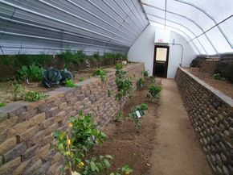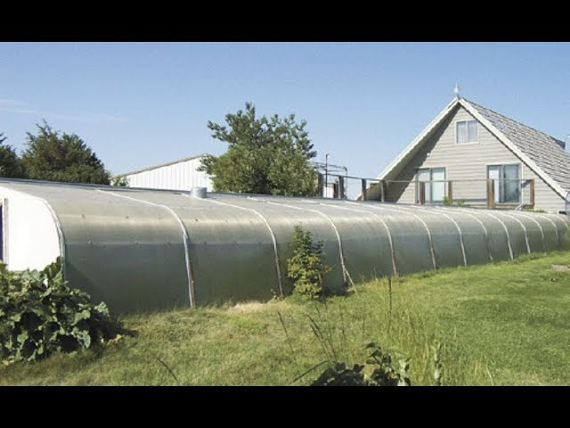
Figure 1 Inside newly built Pit Style Passive Solar Figure 2 External View – roof at ground level

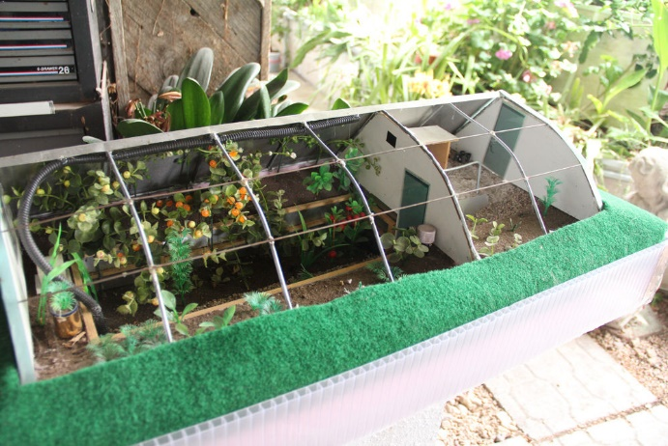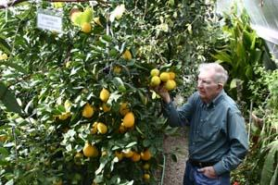
Figure 3 Pit Style Passive Solar Greenhouse Model Figure 4 Russ Finch with his oranges
https://www.youtube.com/watch?v=ZD_3_gsgsnk
Le Jardin des Funambules (Quebec)
- Hoop house with insulated foundation
- $25-30 thousand to build
- Investment of knowledge to grow
- Rocks with French drain around greenhouse
- 32 x 100 ft, 35 x 100 ft, 35 x 105 ft
- Make most money on cherry tomatoes
- Accessibility to farm, greenhouses, and inside the greenhouse super important
- Grow ginger for $40/kilo
- Bring in beneficial insects
- May through October do not need to heat with propane
- Expensive to heat through winter due to designs lack of insulation
- Can produce the most food, best for commercial farming
- Least likely to be a good gathering space
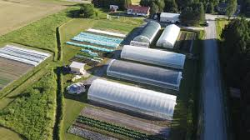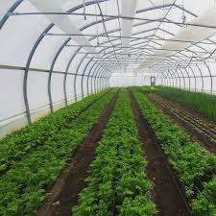
Figure 5 Bird’s Eye view of Hoop house Greenhouses Figure 6 Inside view
http://lejardindesfunambules.com/

Lida Farms Deep Winter Greenhouse/Root Cellar
- Located in Northern Minnesota
- Passive-solar design with solar panels
- Growing cold-tolerant greens
- Storage crops stored in an attached root cellar
- Small cottage provides back wall for greenhouse
- Hillside topography to provide more constant temperatures
- Building well below the frostline
- Greenhouse stands 16 feet tall
- Four feet below grade have an insulated foundation with tiling and rock for a solar air heat sink and the radiant floor tubing connected to the solar panels
- Ties into existing infrastructure with an outdoor wood boiler for back up heat source
- 32 x 16 feet
- Double-walled polycarbonate (retains more heat than plastics)
- Root cellar 9 x 14 feet beside the greenhouse
- Made with simple timber construction
- Using evacuated solar thermal tubes for heat
- Costs
  - Greenhouse
    - Excavating: $1841 USD
    - Labour: $1330 USD
    - Plumbing: $1837 USD
    - Materials: $4273 USD
    - Lumber: $7589 USD
    - Solar: $7057 USD
    - Total: $23,928 USD or $30,494.44 CAN
  - Root Cellar
    - Excavating: $789 USD
    - Labour: $570 USD
    - Materials: $649 USD
    - Lumber: $2710 USD
    - Total: 4,719 USD or $6014.01 CAN
  - Propane in the winter: An average of $300 USD or $382 CAN
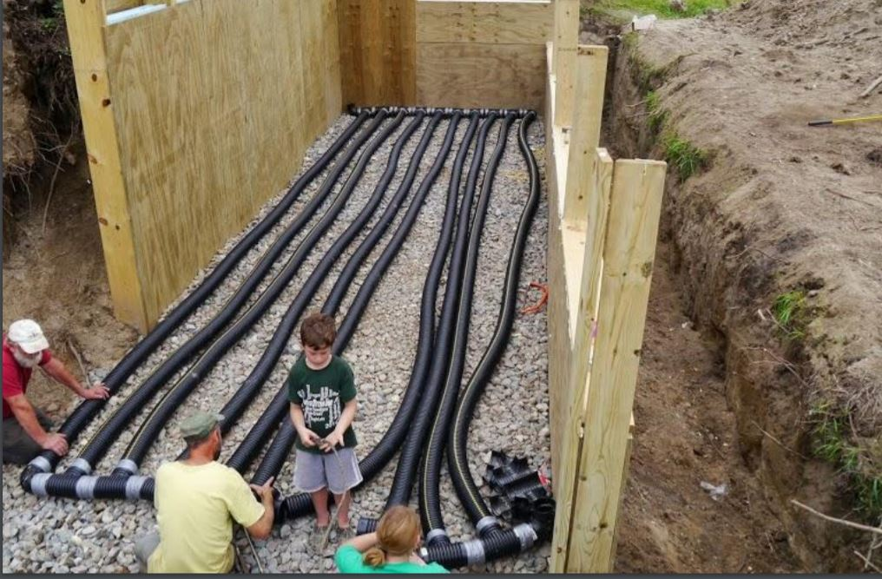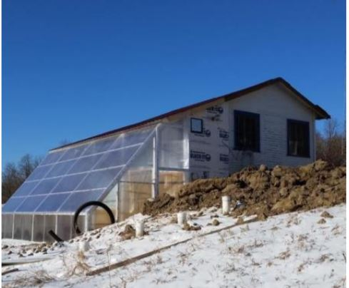
Figure 7 Earth Tubes Figure 8 Pit Style Passive Solar and Root Cellar
https://practicalfarmers.org/wp-content/uploads/2019/04/Ryan-Pesch-Deep-Winter-Greenhouse.pdf
https://www.researchgate.net/publication/280882501_Winter_Greenhouse_Enterprise_Analysis
Rob Avis Passive Solar
- Ventilation
  - Vent wall consisting of low and high vents
- Insulation
  - Standard pink
  - Plastic vapour barrier
  - Sheet metal on outside
  - Side walls are white sheet metal for reflecting
- Knee Wall
  - Where the snow will accumulate, place low vents on top of knee wall
- 12% glazing, 90% of heating comes from this
- Rainwater harvesting
  - Free fertilizer
  - Bison pumps to pump rainwater that is just below the surface of the ground
- Plant pollination crops at front of greenhouse in front of vent wall so pollinators will go into the greenhouse
- Problems in greenhouses
  - Pollination, spraying fish emulation to attract pollinators
  - Not having enough air flow
    - Need cross ventilation with windows and door
- Overhead insulated garage door
  - Provides easier access for heavier work
- Foundation
  - Insulated concrete forms down four feet from soil level
- Structure cost
  - $65-70 thousand with construction
  - $30-40 thousand for just materials
- Heat storage
  - Climate batteries
    - Store thermal energies, diurnal system
- Solar Air Collector
  - Soffit – sheet metal with perforations to allow air flow
  - Used as solar air collector
- Energy stored in fall keeps greenhouse warm in winter
- Does not grow all four seasons because he does not want to use external heating sources
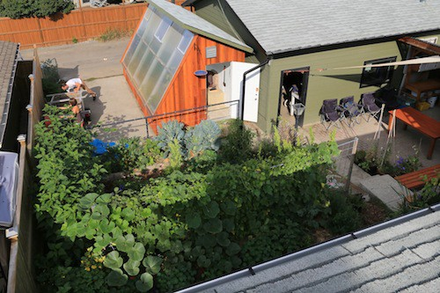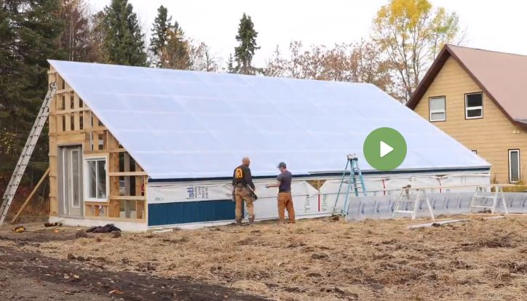
Figure 9 Rob Avis First Passive Solar Design Figure 10 Rob Avis Second Passive Solar Design
https://vergepermaculture.ca/passive-solar-greenhouse/

