A-Frame Greenhouse $25 per sq. ft | 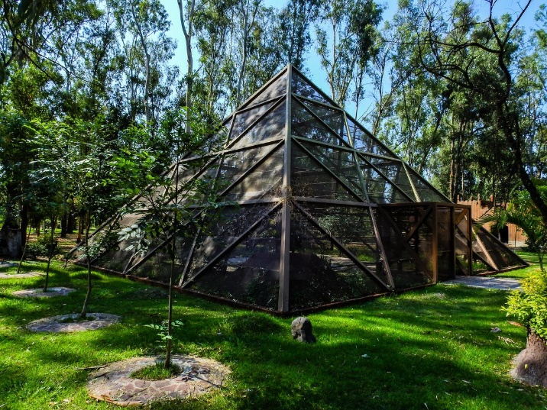
Gothic Arch Greenhouse $25 per sq. ft | 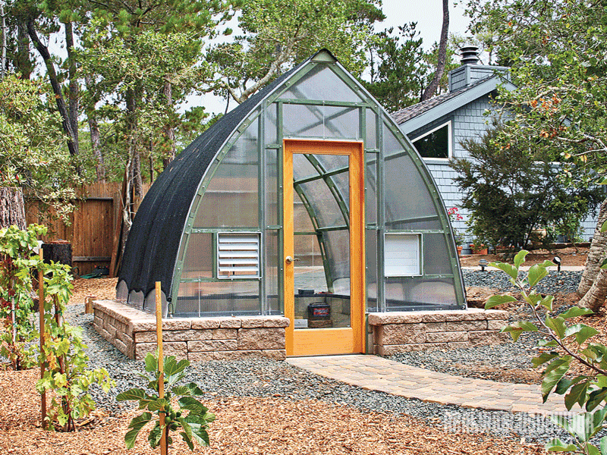
Lean-to Greenhouse $10-$25 per sq. ft | 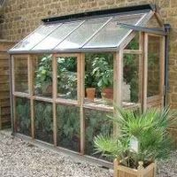
Dome Greenhouse $33 per sq. ft | 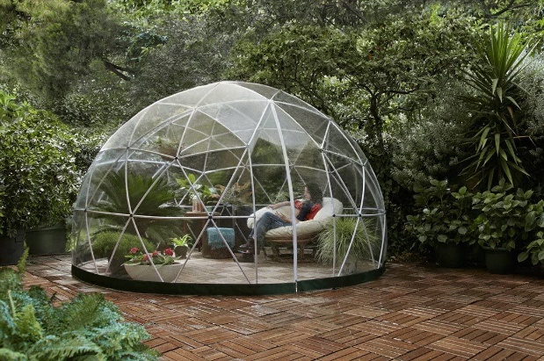
Hoop Greenhouse $5-$10 per sq. ft | 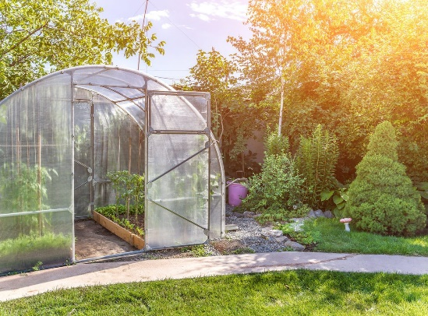
Pit Greenhouse $6-$12 per sq. ft | 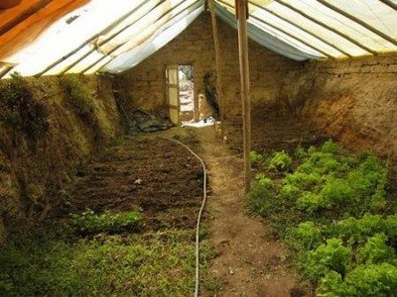
Barn-style Greenhouse $25 per sq. ft | 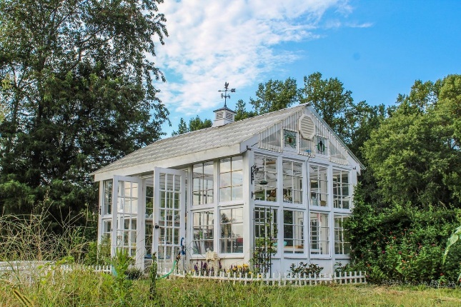
Passive Solar Greenhouse $20-30 thousand (Marty and Melanie), $65-70 thousand (Rob Avis estimate with builder), $30-40 thousand (Rob Avis estimate of materials), $25,000 (Carsons’ estimate) | 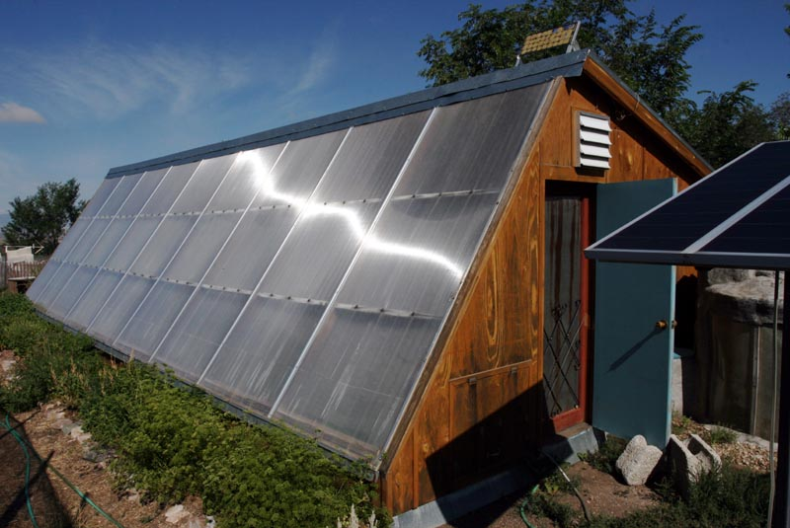
Chinese Style $30,000 | 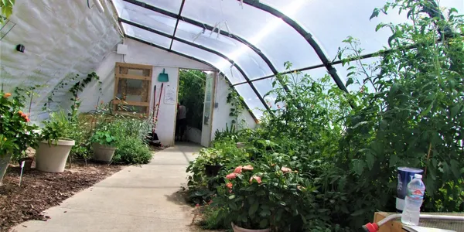
Conventional Greenhouse $25 per sq. ft | 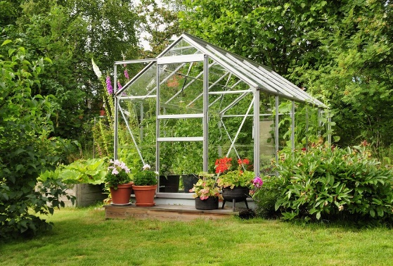
Shipping Container $15,000 | 