SAVING WEAK COLONIES IN THE SPRING

Marlowe Sharp
Glorybee Apiary
Loring, On
glorybeeapiary@gmail.com

As I write this out I am enjoying a really good March thunderstorm which is clearing much of the dirt stained snow and uncovering the first crocus shoots in the garden. Spring is coming!

In the fall of 2019 I was, to my shame a bit lax in doing my mite checks, assuming that because of all the splits I had done and selling and adding new queens to most of colonies, the mite cycle would have been broken enough to keep the mite population down in my75 ( mostly single brood chamber) colonies. I thought wrong. I was alarmed when I did a few spot checks at feeding time and found high mite levels. Further, I was very concerned that the current bees may have been already weakenened and that brood that had not yet emerged would be affected also. All winter it's been on my mind as I prayed "God let my bees survive and I promise I'll offer to speak at more bee meetings!", (don't we all make deals with God when we're desperate - LOL???)

Come mid March I couldn't stand it anymore. So, with the first decently warm day and even though it was a bit earlier than I like for being this far north, I started lifting lids. What I saw wasn't as bad as I had imagined, but not as good as I'd normally hope for; 7 deadouts and 9 weak hives – weak enough that I was fairly certain they would perish or have to be united before pollen and nectar appeared, especially if we had an extended cool spring like last year. The weak colonies ranged from 1 to 3 frames of bees.

Colonies could weaken to the point of being unable to survive for a number of reasons including dwindling food resourses or maybe the cluster was smaller starting the winter and now had died back enough that it can't generate enough heat to keep going.

Consider this: colonies that go into the winter in less that perfect shape, won't be in better shape come spring. When one considers that a queen tends to lay brood in an area that can just be covered by the bees, a small cluster of bees, even if they make it through until the nectar flow begins might not be able to develop enough to get started and grow into a strong colony by fall. If you take into account the time required for brood to hatch etc, the logistics simply work against her building up the population. A failing hive might not be the queen's fault either so saving the queen, at least to start the new season may be worthwhile. WHAT TO DO?

About 4 years ago at a Spring OBA meeting, Fletcher Colpitts, a beekeeper from New Brunswick spoke about his method of saving weak hives in the spring by placing a weak hive above a strong one and running it as a 2 queen colony until later in the spring. I checked my 2016 notes and then gave Fletcher a call to ask a few questions. One of the things I love about our beekeeping community is that most are willing to sit on the phone at a moments notice and answer anything bee related to help out others. Fletcher had modified this process a bit since he gave the talk but the following description speaks to what he does, what I did, and upon checking one of my 9 combined colonies what I found.

NOTE OF CAUTION: A colony that has contracted dysentary (a possible indicator of Nosema and evidenced by a large amount of bee feces in the hive and at the upper entrance) over the winter is one situation that I would not consider for this proceedure for fear of spreading the problem onto a healthy population of bees.

For each colony you are trying to save you need:

- a sheet of air foil insulation (that silver foil coated bubble wrap stuff used to wrap your water heater – sold under the brand name Reflectix) to use as an inner cover. Cut it a about a 1/2" larger all around than an inner cover and cut a 4' diameter hole in the center.
- a wooden rim 1 – 1 1/2' deep, (also called an "eke" – see March's OBJ article by Kelly Rogers)
- a queen excluder ( make sure it's not damaged allowing a queen to pass through)
- pollen patties ( I use 2 per hive)
- 1 kg dry sugar

Next, identify the weak colonies in your yard which for me, at this time of year is anything 3 frames of bees or less *. Anything 4 frames or larger with the addition of pollen patties and sugar should survive. Now, identify your very strongest ones. Your strong ones should be a good 8 frames strong or better to have enough resources to help the weaker one.

Open your strong hive and remove the inner cover. Place 1 or 2 pollen patties directly on the top bars of the strong colony being careful not to place them where the hole of the air foil inner cover will sit. Place the air foil inner cover on followed by the eke (wooden rim). The pollen pattie bulges up a bit which is why you need the eke to provide a space between the two colonies. Without it the bottom bars of the weak hive would push up when placed on the strong one.

The air foil inner cover and eke now gives you a nice platform onto which you can pour 1 kg or more of sugar . The colony may not need the sugar but I'd rather err on the side of caution should cool spring weather extend longer than usual. (What is "usual" weather these days anyhow?)

On top of the eke, place your queen excluder and then the weak hive. This set up will allow for the following:

- the 4" hole in the air foil will allow warm air to rise up to the weaker colony and keep them
warm.
- bees from the strong hive will migrate up to the weaker hive and help care for the queen and move resources around to benefit both colonies.
- as more bees emerge below and move up above the population of the hives will equalize. When food becomes available, the top colony now growing strong with a good population can be placed back on it's own bottom board and continue under it's own steam.

The series of 6 photo below shows the stages of assembling the 2 queen double brood box colony. .

- strong hive with pollen patties
- air foil inner cover with sugar, eke and queen excluder placed on
- weak hive placed on top
- wrap replaced
- 9 days later the colony has gone from 2 frames of bees to (It is stronger than it looks but I smoked them down before takeing the photo...Duh!)
6. the queen from the weak hive now with warmth and increased care is starting to lay well
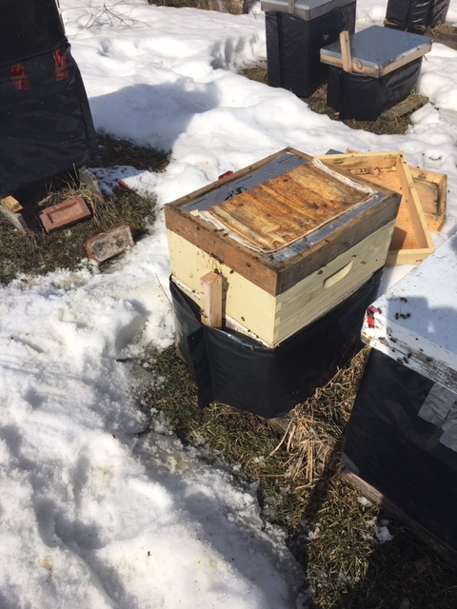
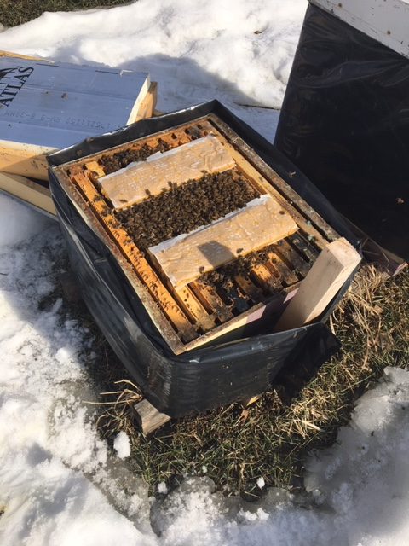
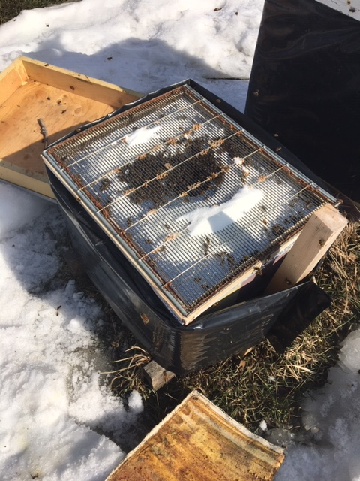

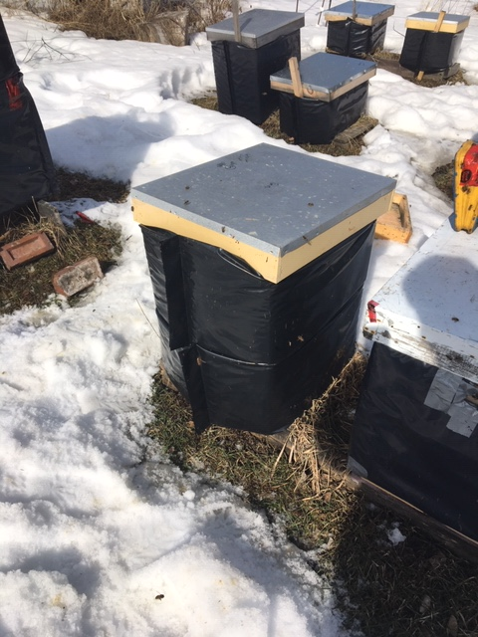
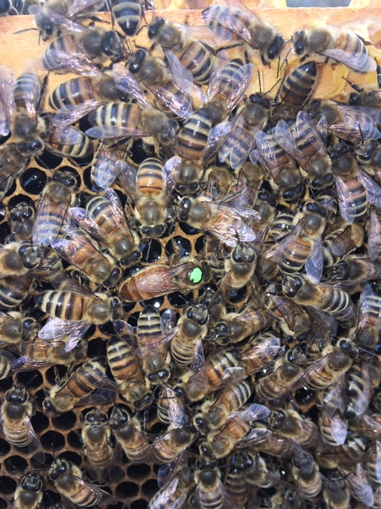
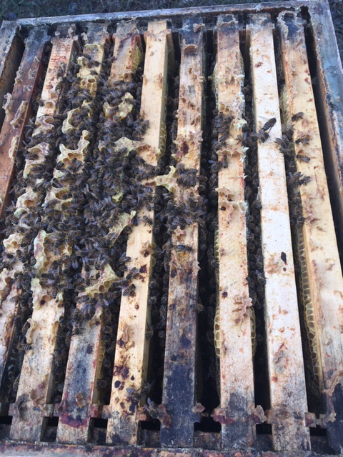

This is the first year I've tried Fletcher's method. I really wish I would have taken an initial photo of the weak colonies. I combined my weak colonies in this fashion on March 19. I checked one colony March 28 and found it to be progressing nicely with the queen now laying a very nice pattern as opposed to the area before where I had found a tiny patch of capped brood just emerging. This means that she actually started laying near the end of February. When the next warm stretch arrives, forecast for the first week of April I'll check the others.

I hope this helps some save a few colonies.!

Let's bee keepin' it real! Stay healthy everyone!

* I may try experimenting with this method in the fall if I have a colony started late that might not
be up to strength or have enough stores. In this case I'd define "weak" as a colony with less than
5 frames of bees. Normally one might just unite them but I'm going to consider trying to keep
both queens going in order to start a colony in the spring with a queen.

