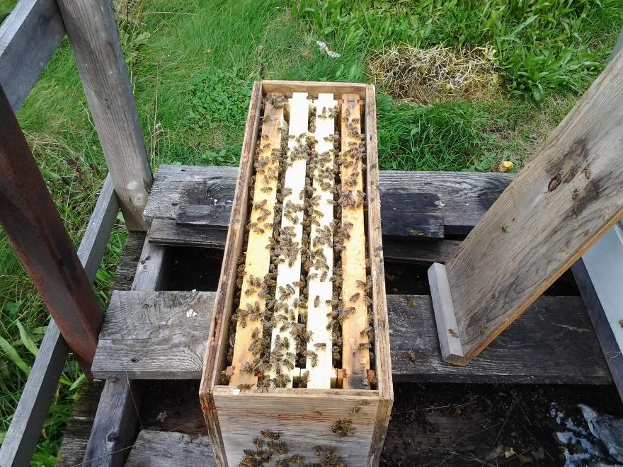

Ferrier’s Maplebee Farm
beekeeping guide
Scott Ferrier |Beginning Beekeeping | April 24 2017

Nucleus Colony Installation
Before you pick up your nucleus colony it is a good idea to pick the location that you want to set up your bee yard. You then want to set up your electric fence and put something on the ground to set the bee hive on as you don’t want it directly on the ground as it will just allow easy access for snails, snakes, and other creature the bees don’t need to be bothered by. It will also keep your equipment dry and help keep moisture out of the hive.
When you pick up your nucleus colony it will most likely be in the evening as the field bees will be back in for the night. That is also the best time to transport bees as they are calm and rarely come out of the hive and are kept cool in transit as there is no sun to shine on the box and over heat them.
When you get home take the nuc and put it in the spot you are going to have the hive or if you already have the hive sitting there just set it on top of the hive. Wait 10 minutes for them to calm down then pull the screen out of the front entrance and walk away. Don’t stand there they can find you at night and they will not be happy because they don’t like when people mess with them after dark. By removing the screening on the evening, you bring them home you don’t have to worry about them the next morning to much even if you must leave them all day they will be fine and when you go to work with them they will be calm as they aren’t held captive. As like everything else in the world they don’t enjoy being screened in because they can’t protect themselves.
The next day go out make a space in the center of you hive that will accommodate 5 frames. Open your nuc and slowly remove an outside frame and place it in the hive then pull each frame from the nuc and put in into the hive in the same order as you take them out of the nuc. Then put one more frame in from the frames you removed to make the space, put your inner cover and lid on and walk away for a few days at least. There will be a lot of activity at the hive for a few hours as they figure out where they are.
If you are starting with a nucleus colony the main thing you need to do all summer is keep giving them room to grow without giving them to much room to have to heat. As each super gets about ¾ full you need to give them another and the warmer it is out the more room you need to give them. Sometimes a nucleus colony will do fantastic some even making as much as 50 lb. of honey others won’t make any honey the first year but are ready for the second year to make over 100 lbs. of excess honey.
Here is a good rule of thumb for beekeepers and working with bees. If possible work with your bees on nice sunny days above 8 degrees C. The best time to work them is between 10 am and 4pm this way most of you foraging bees are in the field so the hive isn’t so packed with bees which makes it easier to see what you need to see.

Now we will start at the first of the year.
January- Your bees are in their cluster and you shouldn’t have to do anything with them. If you want you can go out and make sure the entrances are clear.

February- Still pretty much nothing you can do. Should make sure your entrances are clear as you may get a couple of days above zero and any frost on the inside of the hive may melt creating condensation so you need the air circulation to remove the moisture.

March- This is the beginning. Around the 15th on a day that is warmer I would say above 6 degrees C. go and take the top of you hive remove the inner cover insulation and look and listen if you hear no noise and see no bees keep going take off the inner cover and find out if your hive is alive or dead. If it is alive put on a pollen paddy and put on a feeder with 1 to 1 syrup that’s one part sugar to one part water by weight. Then wrap your hive back up make sure your entrances are clear and walk away. What you have just done is stimulated your bees into thinking there is pollen and nectar flow which will get them to start producing brood to bring the population up earlier so your bees will be strong enough to split or go into honey. It will also help to keep them from starving if they are low on stores. If it is a warm March you need to keep checking your feed level as once you start feeding and they start producing brood they begin to use up the feed and stores to feed the young. If you start feeding you need to continue because if you don’t you can cause your colony to starve.
April- The first half of April is usually not much different then March, keep the feed coming. I know it sounds like your feeding a lot of feed but they really don’t take down much feed in the cold weather so it all depends on the year. The second half of the month is a little different. It is warmer and the bees can get out of the hive for cleansing flights. You will notice the bees are mostly using the upper entrance. This will change within the next steps you take. It is time to take the winter wrap off. Take the top off and the inner cover and see how many frames of bees you have left. If your hive is strong it will have lots of bees and lots of brood, if your hive is weak you will have very little brood, if the queen has died during winter you will have no brood no matter how strong your hive is. No matter what you find the next step is just doing a spring cleaning. Go over each frame and remove anything that shouldn’t be there like dead bees which at this point will have started to mold. Don’t worry about the mold just get rid of the dead bees. The bees are very good at cleaning out mold and mildew. Usually at this point the outside frames have a little mildew on them and they are usually full of honey so just take them and switch them for the frame beside them and the bees over the next little while will clean them up. Keep going through the hive one frame at a time removing all the bees remove the top box and go through the bottom box doing the same thing them remove the bottom box to expose the bottom board which will be covered in dead bees and debris from the whole winter. Scrape it off onto the ground and put the box that was your top box on the bottom board and then the bottom box on top of the box that you just put on the bottom board basically reversing the boxes positions. This will get the bees to start the cleanup of the box that they have been ignoring all spring and will open up a hole box of empty frames for the queen to lay in. before you put your inner cover back on put on foulbrood mix (oxytet) this is treatment for foulbrood you should put on 3 tablespoons 3 times in 5 day intervals. This treatment has to be bought from a vet. They will want your registration number so you have to register your bees with Ontario Ministry of Agriculture Food and Rural Affairs (OMAFRA). After you do this you will notice the bees are going to use the bottom entrance as well as the upper entrance because the bottom entrance is now the closest and is now free of debris. You have just saved your bees a huge amount of work leaving their time for more important things like taking care of the brood, cleaning cells and gathering pollen which they will be able to get now as the trees are starting to bud.
May- this month gets a little more challenging for the first two weeks you need to keep an eye on how much room they have. There is still not much nectar for them to get so watching their food supply is still important. And you need to check for varroa you can use an alcohol wash and count them before you decide if you are going to treat them or not or you can just treat them. There are several ways to treat them you can use mite away strips, formic acid with pads, apistan or apivar. Mite away and formic acid with pads must be use when the temperature is high enough for them to work. Apistan and apivar can be used at any temperature. They are going to be getting much stronger and in the second half of the month you really need to keep an eye on them for swarming. If they have been doing well all spring you have the choice of splitting your hive. There are many ways of doing this you can just put open brood with eggs and young larva in each box and separate them and the one without a queen will make their own. You can also find your queen and separate them keeping track of where the queen is then buy a queen for the half that doesn’t have one. There are good and bad things about both ways of doing it. Add a second box to each part of the split. If your hive is not that strong this is the time for them to bring in the nectar they need to expand back into a healthy hive again. I usually let them take in lots of pollen and nectar to fill their hive up all the time watching them for swarming which is caused by their hive being too full of bees, brood, and nectar/honey.
June- If you did not split your hive check it for room. If they are getting full make sure all types of medication are off and put on your queen excluder and put a honey super on top of that with 9 frames spaced evenly across the box. Over the next few weeks I would still watch these hives for swarming as sometimes the basically refuse to go up and work that empty super and will just stay in the brood chamber and get too full and swarm. From this point to the end of summer you need to keep checking your hives for room if they run out of room they will swarm so just keep stacking honey supers on when the one before is getting full.
July- Keep giving them room by mid-July you may have some honey supers that are full and capped that you can take off and extract the honey. Don’t forget to replace you honey supers that you take off as they are so full of bees they can’t fit in just the two brood chambers anymore they need those honey supers on there or they will swarm on you. At this time of year, it is all about the space they have and actually, all through summer they just keep expanding and that is how we can take advantage of them and take honey for ourselves. I don’t considerate stealing honey because without us watching their mite levels and such they would not be able to continue living.
August- continue to monitor them for space and at the end of the month take off all the honey supers and extract the honey. Don’t worry there will be room in the brood chamber for them to keep bringing in what little nectar is left for them to collect.
September- 1st start treatment for varroa mites. On the 15th start feeding to fill up the hive. This time of year, it should be 2 parts sugar to 1 part water. Also put on foulbrood mix (oxytet) that you get from the vet.
October- check the weight of your hives if they are still a bit light feed more syrup. Hopefully they are not because it is getting cooler and they have less chance to cap it leaving open cells of feed which is just moisture in the hive. That is why it is important to feed heavy is September as soon as the natural nectar ends.
At the end of October or early November it is time to wrap your hive. Put insulation on top of the inner cover them wrap your hive with whatever you decide to wrap it with there are many options from your own home made idea to easy to use commercial wraps. Whatever you choose to use make sure you keep ventilation at the bottom and top of your hive so the condensation can get out. And don’t forget to put in some sort of guard to stop the mice from getting in as they love to live in beehives and can do a lot of damage.
December- Have a Merry Christmas

We don’t know what each year will bring when it comes to keeping bees. Just enjoy them. They are fascinating and relaxing.

